Report VR&AR Lukas FRITZ

As a starting point I used the Ray Wenderlich tutorial from the myCourses section and imported VR samples& SteamVR assets.

In the most familiar acuity test, a Snellen chart is placed at a standard distance: 6 meters. At this distance, the symbols on the line representing "normal" acuity subtend an angle of five minutes of arc, and the thickness of the lines and of the spaces between the lines subtends one minute of arc. This line designated 6/6 (or 20/20), is the smallest line that a person with normal acuity can read at a distance of 6 meters (20 ft).

As my chart is at z= 4.9 my camera has to be at z=-1.1 to get the 6 meter distance.



Omegaw {\displaystyle w} Oms is the optotype height and width as it is squared. d is the distance to the chart (6 meters). Theta is 5 arcminutes as specified by Snellen.  
One arcminute is the sixtieth part of an angle so 5/60 degrees.

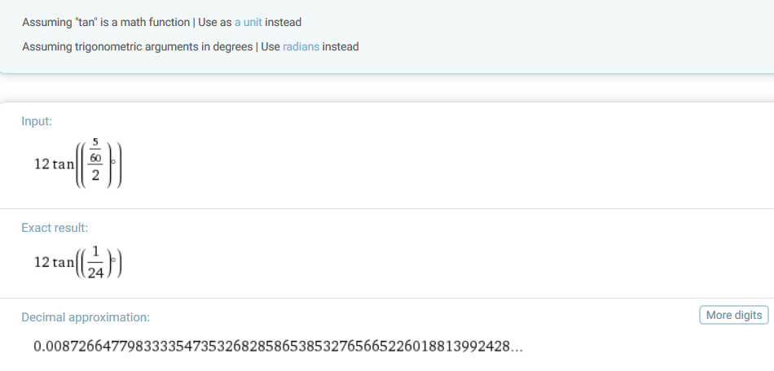

So the top E has to be 87,3mm big to be correctly sized. First I made the mistake to use radians instead of degrees.

I scaled a cube to match 8,7cm and adjusted the size of the graphic that the big E has the fitting size as standard cube is 1meter x 1meter x 1meter.

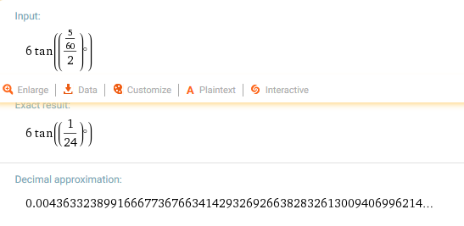

On the floor I have marked the 3m and 6m distance to the chart. You should be able to see the 3rd row from the bottom from 3m and the top 6 rows from 6 meter distance.

The test showed that a ‘normally’ seeing person sees actually less in the virtual world, so would fail the Snellen test and would lose the ability to drive without appropriate glasses.

Resources:

<https://en.wikipedia.org/wiki/Snellen_chart#.226.2F6.22.28m.29_or_.2220.2F20.22.28ft.29_vision>

<https://www.raywenderlich.com/149239/htc-vive-tutorial-unity>